**Sports Management System**

**Software Requirements Specification**

**CEN 3031 Fall 2018**

**Modification history:**

|  |  |  |  |
| --- | --- | --- | --- |
| Version | Date | Who | Comment |
| v1.0 | 10/16/18 | Jake, Andrew, Jordan S, Jordan M, Guilherme, Gregorio | This is the first version of our software |
| V2.0 | 12/1/18 | Gregorio | Requirements 1, 4, 5, 7, 9, 10, 13, and 15 have been edited to be more specific.  Requirements 11, 12, 14, 17, 18, and 19 were omitted due to feedback or were too last minute to implement. |

**Team Name:** Active364

**Team Members:**

* Andrew Wilson abwilson5729@eagle.fgcu.edu
* Jake Sherman jmsherman9253@eagle.fgcu.edu
* Jordon Sasek jsasek5815@eagle.fgcu.edu
* Jordon Moses jmmoses2190@eagle.fgcu.edu
* Guilherme Pereira grpereira1714@eagle.fgcu.edu
* Gregorio Lozada gjlozdada8704@eagle.fgcu.edu

**Contents of this Document**

Introduction

* Software to be Produced
* Definition, Acronyms, and Abbreviations

Product Overview

* Assumptions
* Use Case Diagram
* Use Case Descriptions

Specific Requirements

**SECTION 1: Introduction**

Software to be Produced:

* The software being produced is a sports league management system. Users can create account of different tiers consisting of spectator, team player, and team managers. Spectators, players and managers can follow teams and be notified of their upcoming events, players can request to join teams, and managers can accept players into their team, set up events, and update their team’s scores.

Definitions, Acronyms, and Abbreviations:

* None

**SECTION 2:** **Product Overview**

Assumptions:

* The system assumes users will have a computer.
* The system assumes users will run Microsoft Windows.
* The system assumes users will speak English.
* We assume that the user will only handle our program on their computer and not on a mobile device such as phones or tablets.
* We assume the that the computer the user has will have a minimum of 1GB – 2 GB of memory (RAM) to run our program.
* We assume the computer will have at least above 15% of free space for the program to function properly.
* We assume this product be implemented as a COTS (commercial-off the shelf) product for consumers to use at their disposal.

Use Case Diagram: (Next Page)

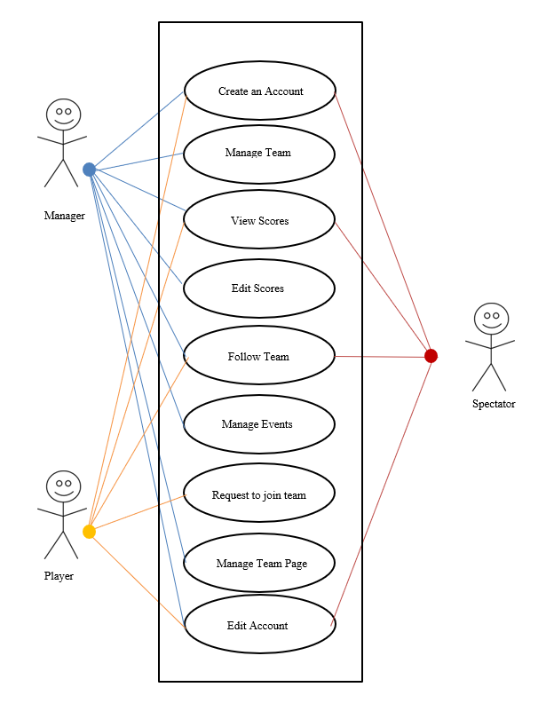

Use Case Descriptions:

* **Create an Account:** Choose between Manager, Player, or Spectator to gain access to different areas of the system.
* **Manage Team:** A manager can access this part of the system to manage their team and accept join requests from players that wish to join the team.
* **View Scores:** Any user can view scores from games played.
* **Edit Scores:** A manager can edit the score of games.
* **Follow Team:** Any user can choose to follow a favorite team.
* **Manage Events:** A manager can create, delete, and edit events that will take place.
* **Request to join team:** A player can send a request to a manager to join a team.
* **Manage Team Page:** Managers can view comments on team page as well as news headlines and events for their team.
* **Edit Account:** Any user can edit their account information including changing their level. (Manager, Player, Spectator)

**SECTION 3: Specific Requirements**

|  |
| --- |
| **No:** 1 |
| **Statement:** The system shall incorporate account creation using the user’s name, a username, and password, account type such as spectator, player, or manager, a team if the user is signing up to be a manager, and account profile picture. Passwords can consist of any characters or numbers, and usernames and teams can be any name as long as it’s not already taken. |
| **No:** 2 |
| **Statement:** The system shall allow users to login into their accounts with their username and password. |
| **No:** 3 |
| **Statement:** The system shall keep a team’s score during events they’re involved with. |
| **No:** 4 |
| **Statement:** The system shall hold account, team, event, and news attributes within text files to be read when the application is booted up. Each line in these text files will consist of a key word indicating what attribute will be read, a colon, and the value of the attribute (e. g. Username:Grego). |
| **No:** 5 |
| **Statement:** The system shall allow spectators to follow teams and view their upcoming events. |
| **No:** 6 |
| **Statement:** The system shall allow team players to request to join teams. |
| **No:** 7 |
| **Statement:** The system shall allow team managers to set up events for their team with name, location, date, time, teams involved, and description. Event name and start date can be anything as long as, the name is not already taken, and date does not overlap with an event that one of the teams involved is also a part of. |
| **No:** 8 |
| **Statement:** The system shall allow team managers to edit the name, location, date, time, teams involved, and description for their team’s events. |
| **No:** 9 |
| **Statement:** The system shall allow team managers to set up a team and accept or deny members to join. |
| **No:** 10 |
| **Statement:** The system shall allow team managers to update scores for their team’s events. |
| **No:** 11 |
| **Statement:** The system shall only permit users to use PNG files as their team or account profile picture. |
| **No:** 12 |
| **Statement:** The system shall write user, team, event, and news data, for example a user’s name, to their respective text files when application is closed. |
| **No:** 13 |
| **Statement:** The system shall provide a “news feed”, consisting of event winners, new teams created, and users joining or leaving a team, depending on who the user is following. |
| **No:** 14 |
| **Statement:** The system shall notify the user of any inappropriate input they have entered in the application, for example entering a username that is already used by another user when creating or editing an account. |
| **No:** 15 |
| **Statement:** The system shall allow users to comment on team pages. |
| **No:** 16 |
| **Statement:** The system shall allow users to change their account type. |
| **No:** 17 |
| **Statement:** The system shall not allow managers or players to follow their respective team. |
| **No:** 18 |
| **Statement:** The system shall allow team managers to change their team name, as long as it’s not already in use, as well as their team profile picture. |
| **No:** 19 |
| **Statement:** The system shall notify users if their edits to their account, team, or event was successful. |
| **No:** 20 |
| **Statement:** The system shall display team scores for ongoing events. |

Template created by G. Walton ([GWalton@mail.ucf.edu](mailto:GWalton@mail.ucf.edu)) on Aug 30, 1999 and last updated Aug 15, 2000; updated by A. Koufakou, Aug 2014

This page last modified by Jake Sherman (<mailto:jmsherman9253@eagle.fgcu.edu>) on 10/16/18